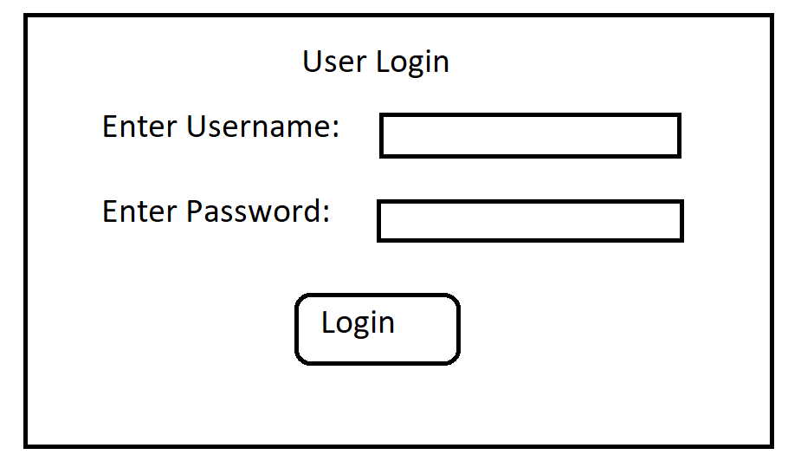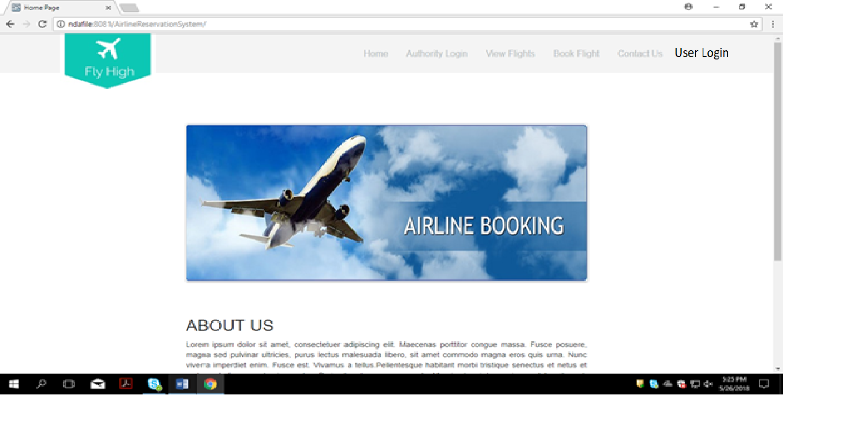User Login Option Added in the Home page

After Clicling on User Login below page will be displayed.

After clicking on login u will be directed to User home page(Welcome to Fly High page.)

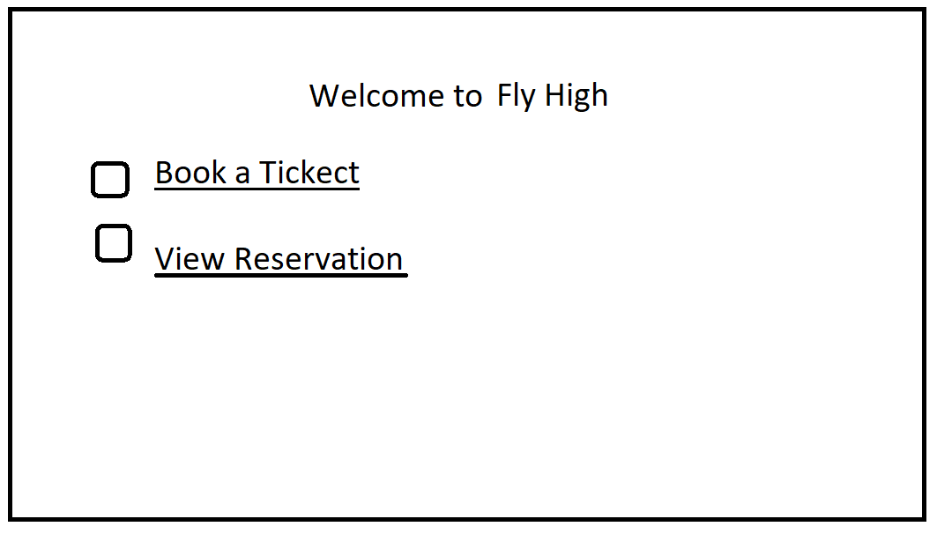

After clicking on book a flight Go to Fly High Bookings page

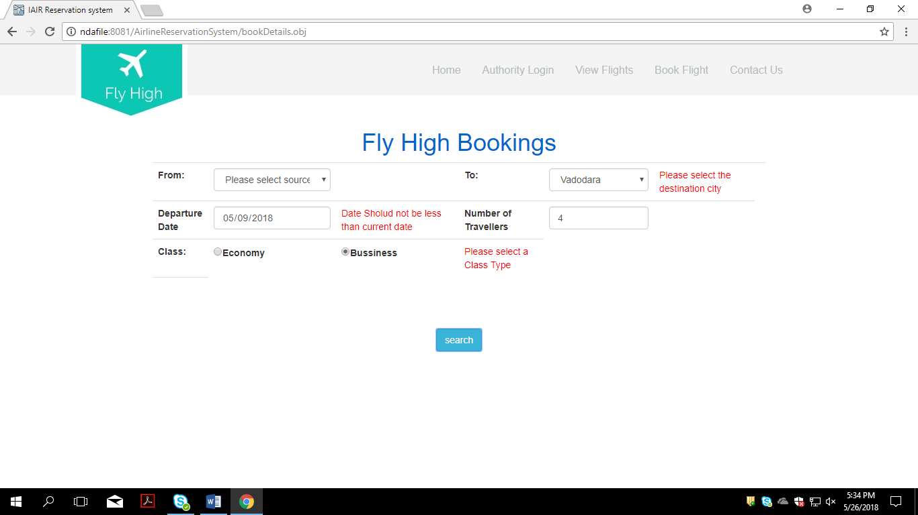

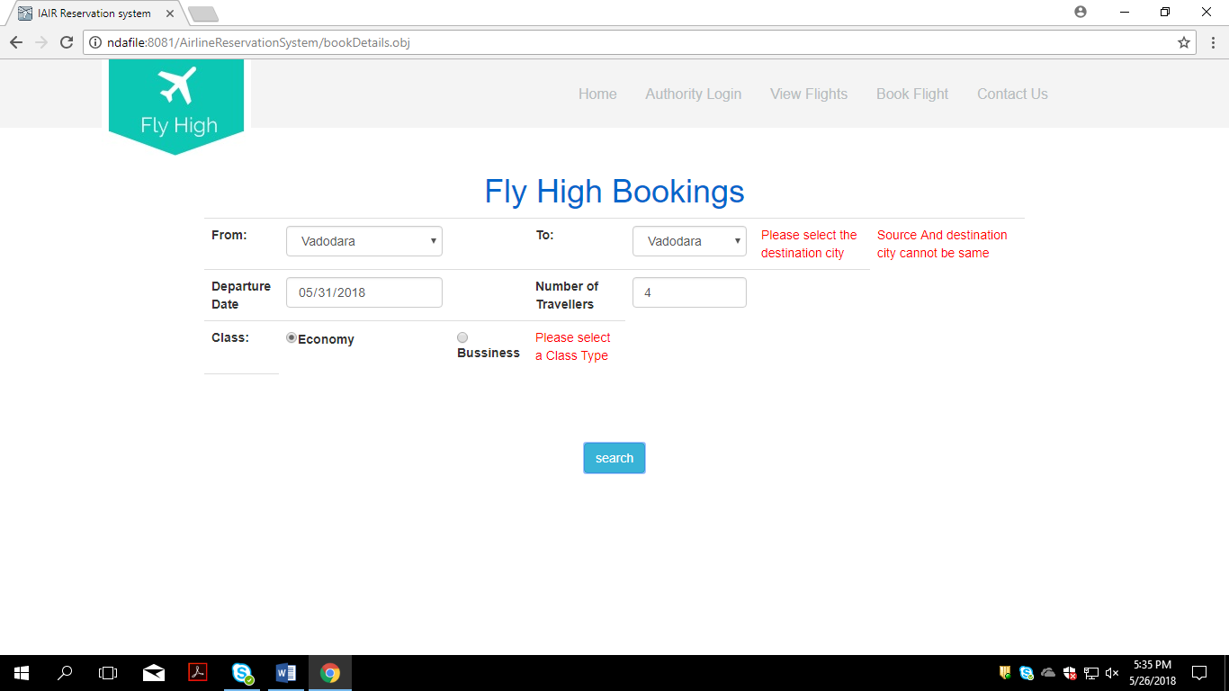

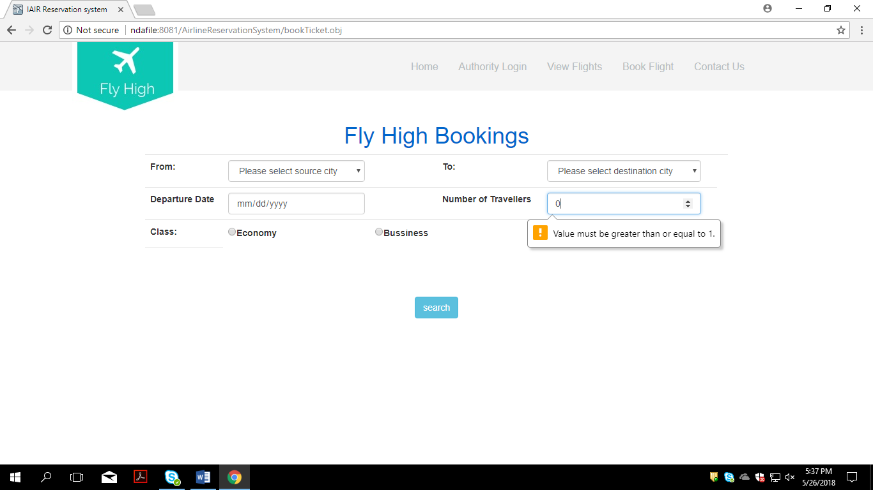

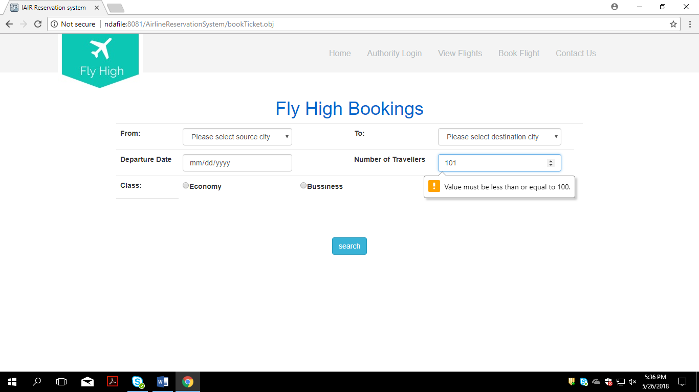

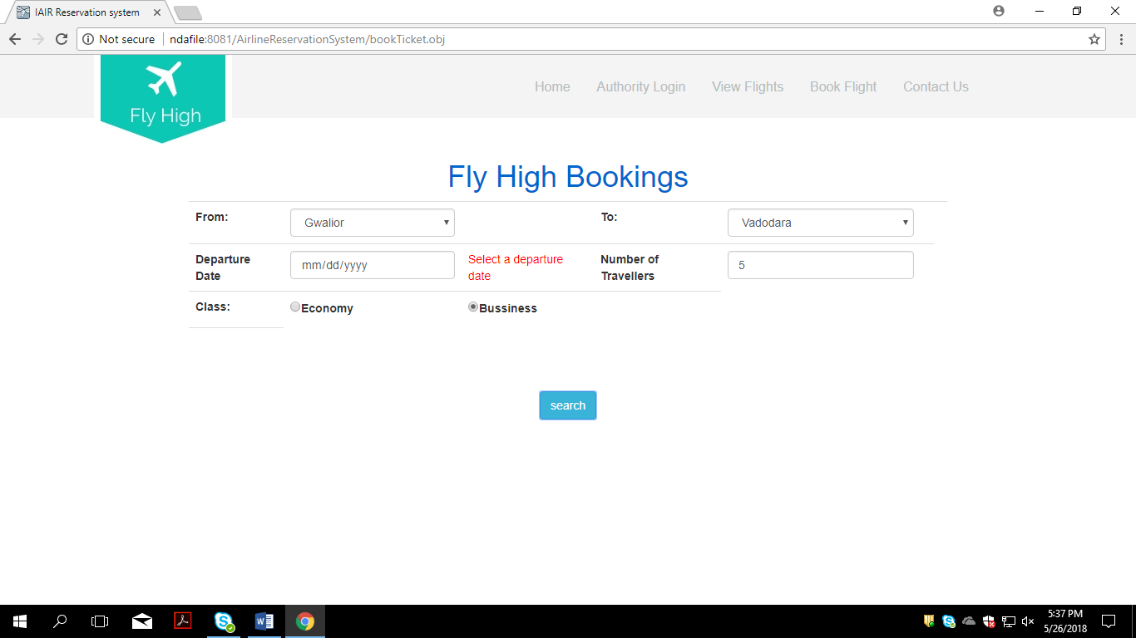

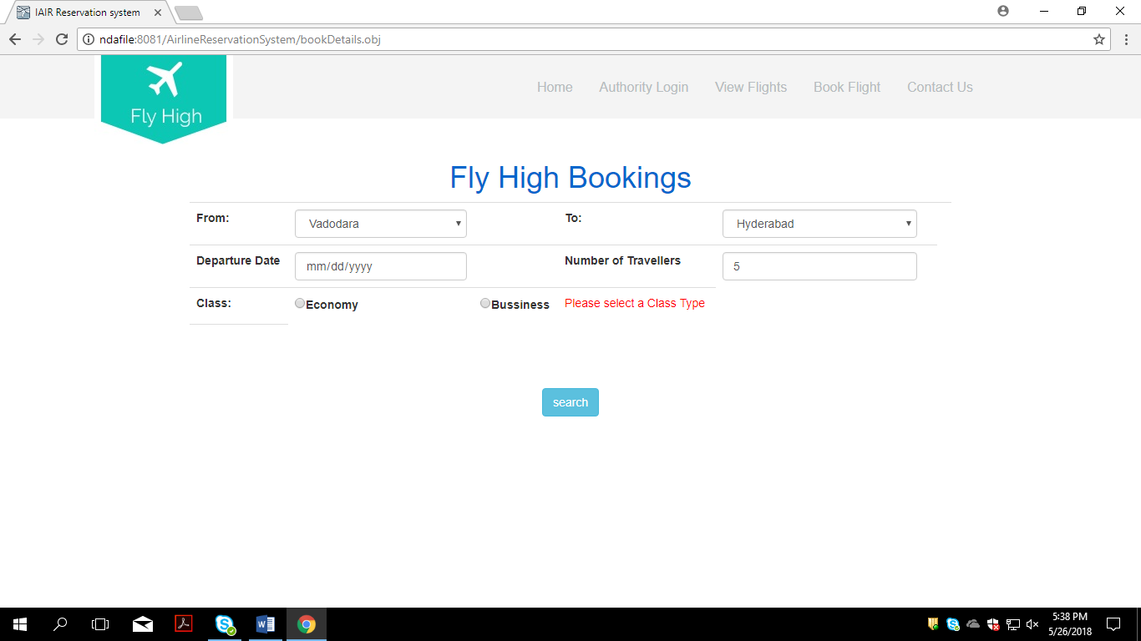

See Each Fly high booking page and write appropriate test cases .

After clicking on search Available flights page will open according to source,destination and journey date.

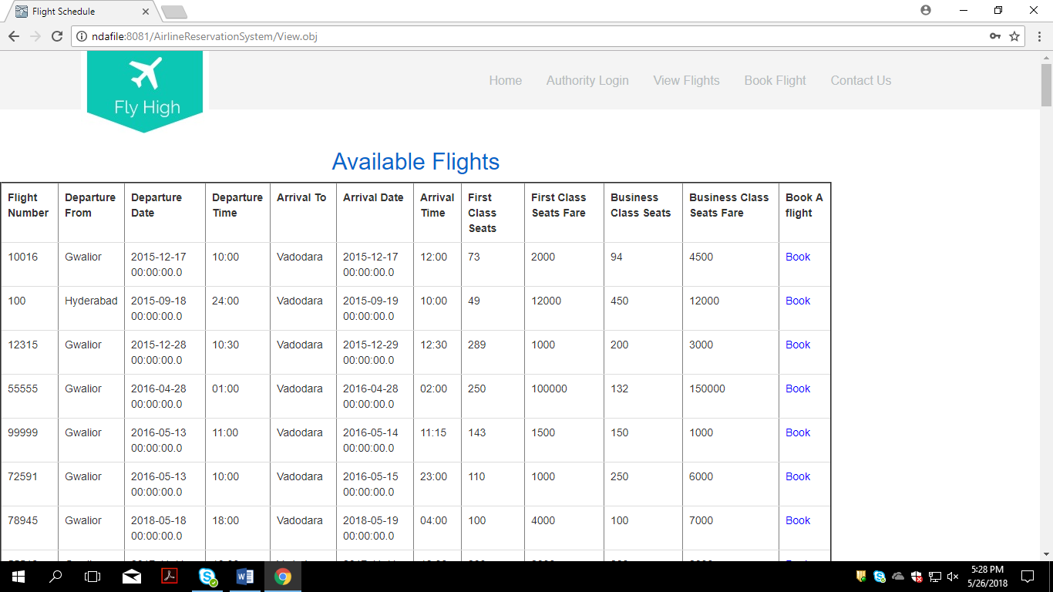

After clicking on book option u will go to booking Informaiton page.

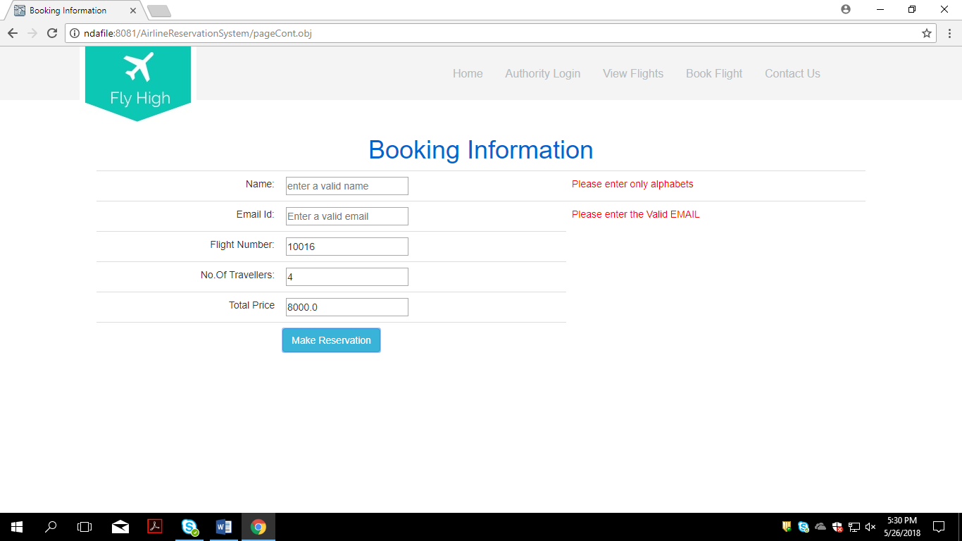

After clicking on Make reservation It will direct u to Your journey details page.

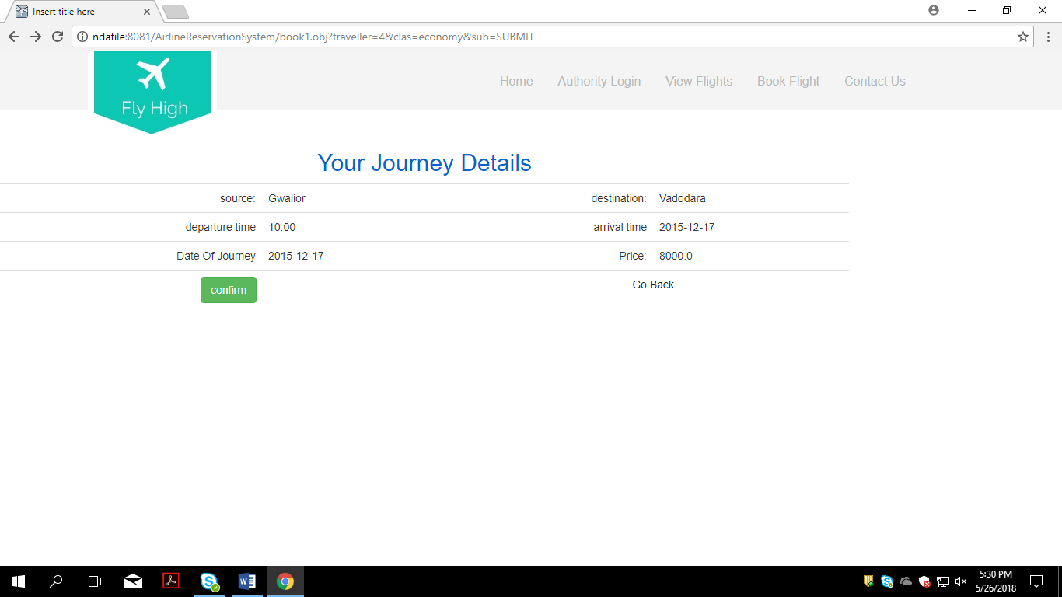

After clicking on confirm u will be directed to payment page

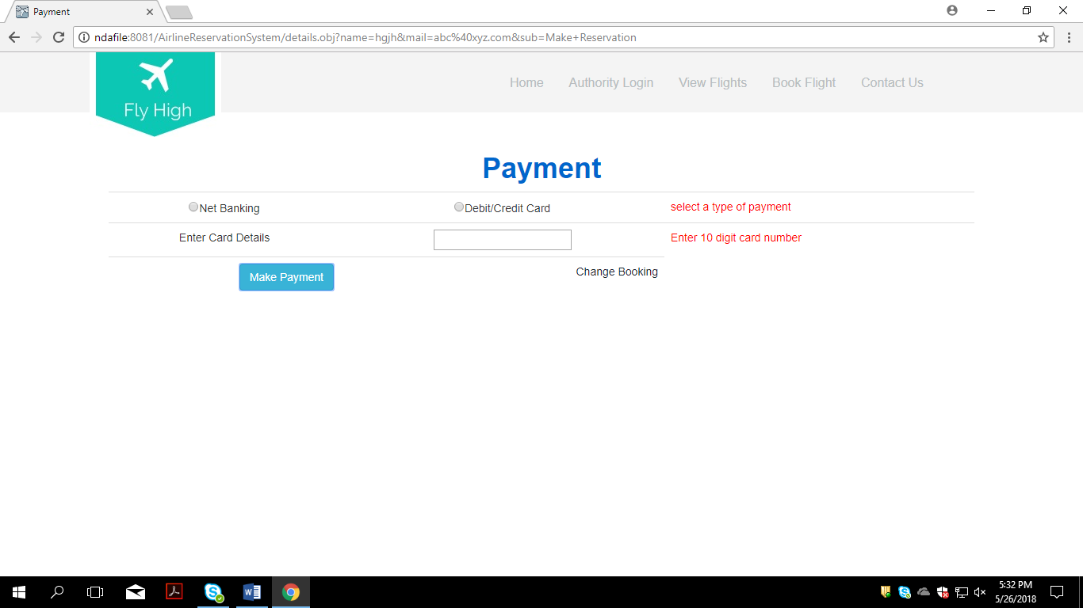

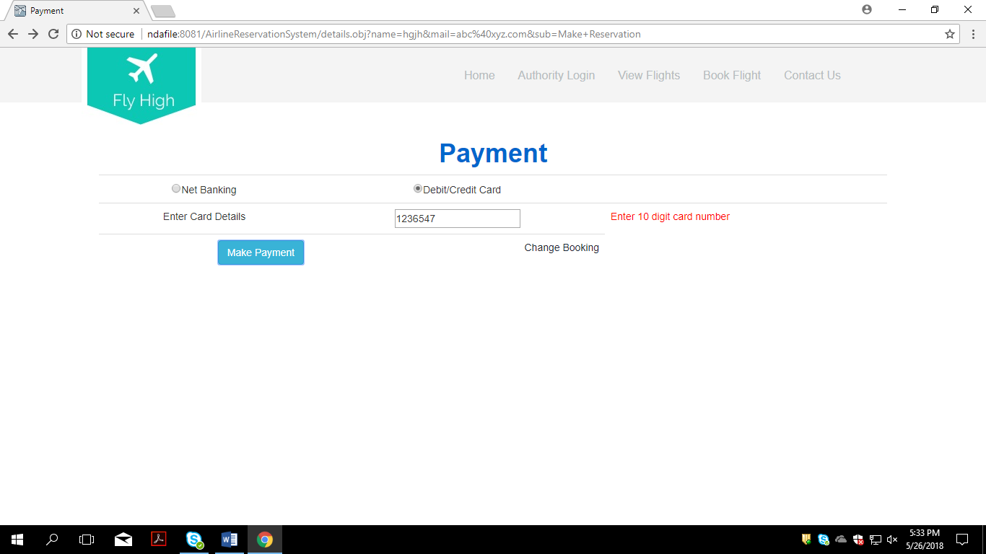

After Clicking on make payment Message “Payment Successful. Your ticket has been booked successfully.” Will be displayed.

View Reservation,Update and Cancel the Ticket

After clicking on View Resrvation It will Direct u to Resrvation Details page.

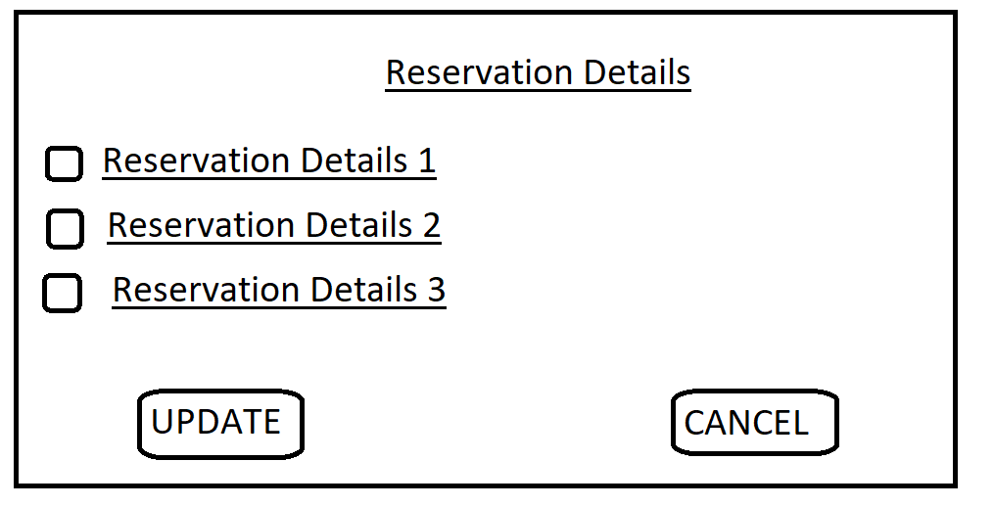

Update:

1. User choosed a particular reservation by clicking on the checkbox.
2. Then Click on update button.
3. After that user could be able to update the details in the same page.
4. After updating click on save button.
5. Message”Your details has been updated successfully.” will get displayed.

CANCEL

1. User choosed a particular reservation by clicking on the checkbox.
2. Then click on cancel button.
3. Message”Your booking has been cancelled successfully.” will get displayed.

ADMIN Operations

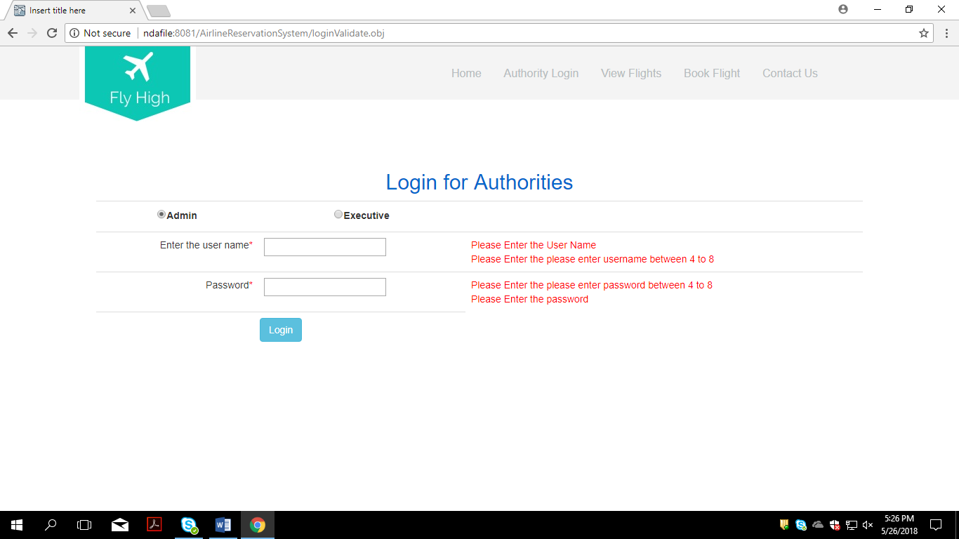Admin Click on Authority login Option on the home page of the application. Then below page will be displayed.

After successful login Admin home page will be displayed.

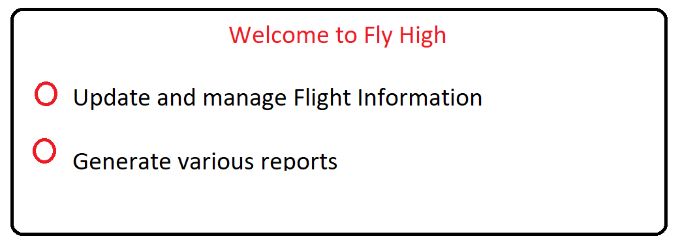

After clicking on Update and mange flight information admin will be directed to Available flights page with add flights, delete flights and update flights info buttons.

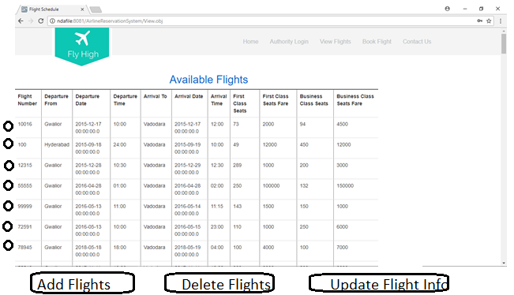

Add Flights

1. Admin Clicks on add flights option
2. Admin has to enter the flight details according to the above image.
3. Click on ADD button.
4. Message”Flight has been added successfully.” Will get displayed.

Delete Flights:

1. Admin selects the particular flight he want to delete by clicking on the radio buttons.
2. Click on Delete flights button.
3. The particular flight gets deleted and appropriate message is displayed.

Update flights:

1. Admin selects the particular flight he want to update by clicking on the radio buttons.
2. Click on Update flight info button.
3. He could be able to edit the informations in the same page.
4. Click on update button.
5. Flight info gets updated.

Generate various reports:

By clicking on admin will be directed to below image and by these three options admin can generate various reports.

